Visitors to the Guru Bar

The organization needs to assess the effectiveness of internal guru bar – where the employees go to have their laptop and network issues handled. Using the data provided, determine the distribution and the statistics necessary to characterize the flow of customers at the Guru Bar and answer the following questions.

What is the probability that there will be 6 customers at the bar in a given hour?

What is the probability there will be between 0 and 6 (or up to 6) customers in a given hour?

What is the probability there will be more than 6 customers in a given hour?

Step 1:

Open the data file and observe the columns. The first column is a randomized ID and the second is a count of customers at an hour measured. Each measurement is taken for an hour, but the actual times are not noted.

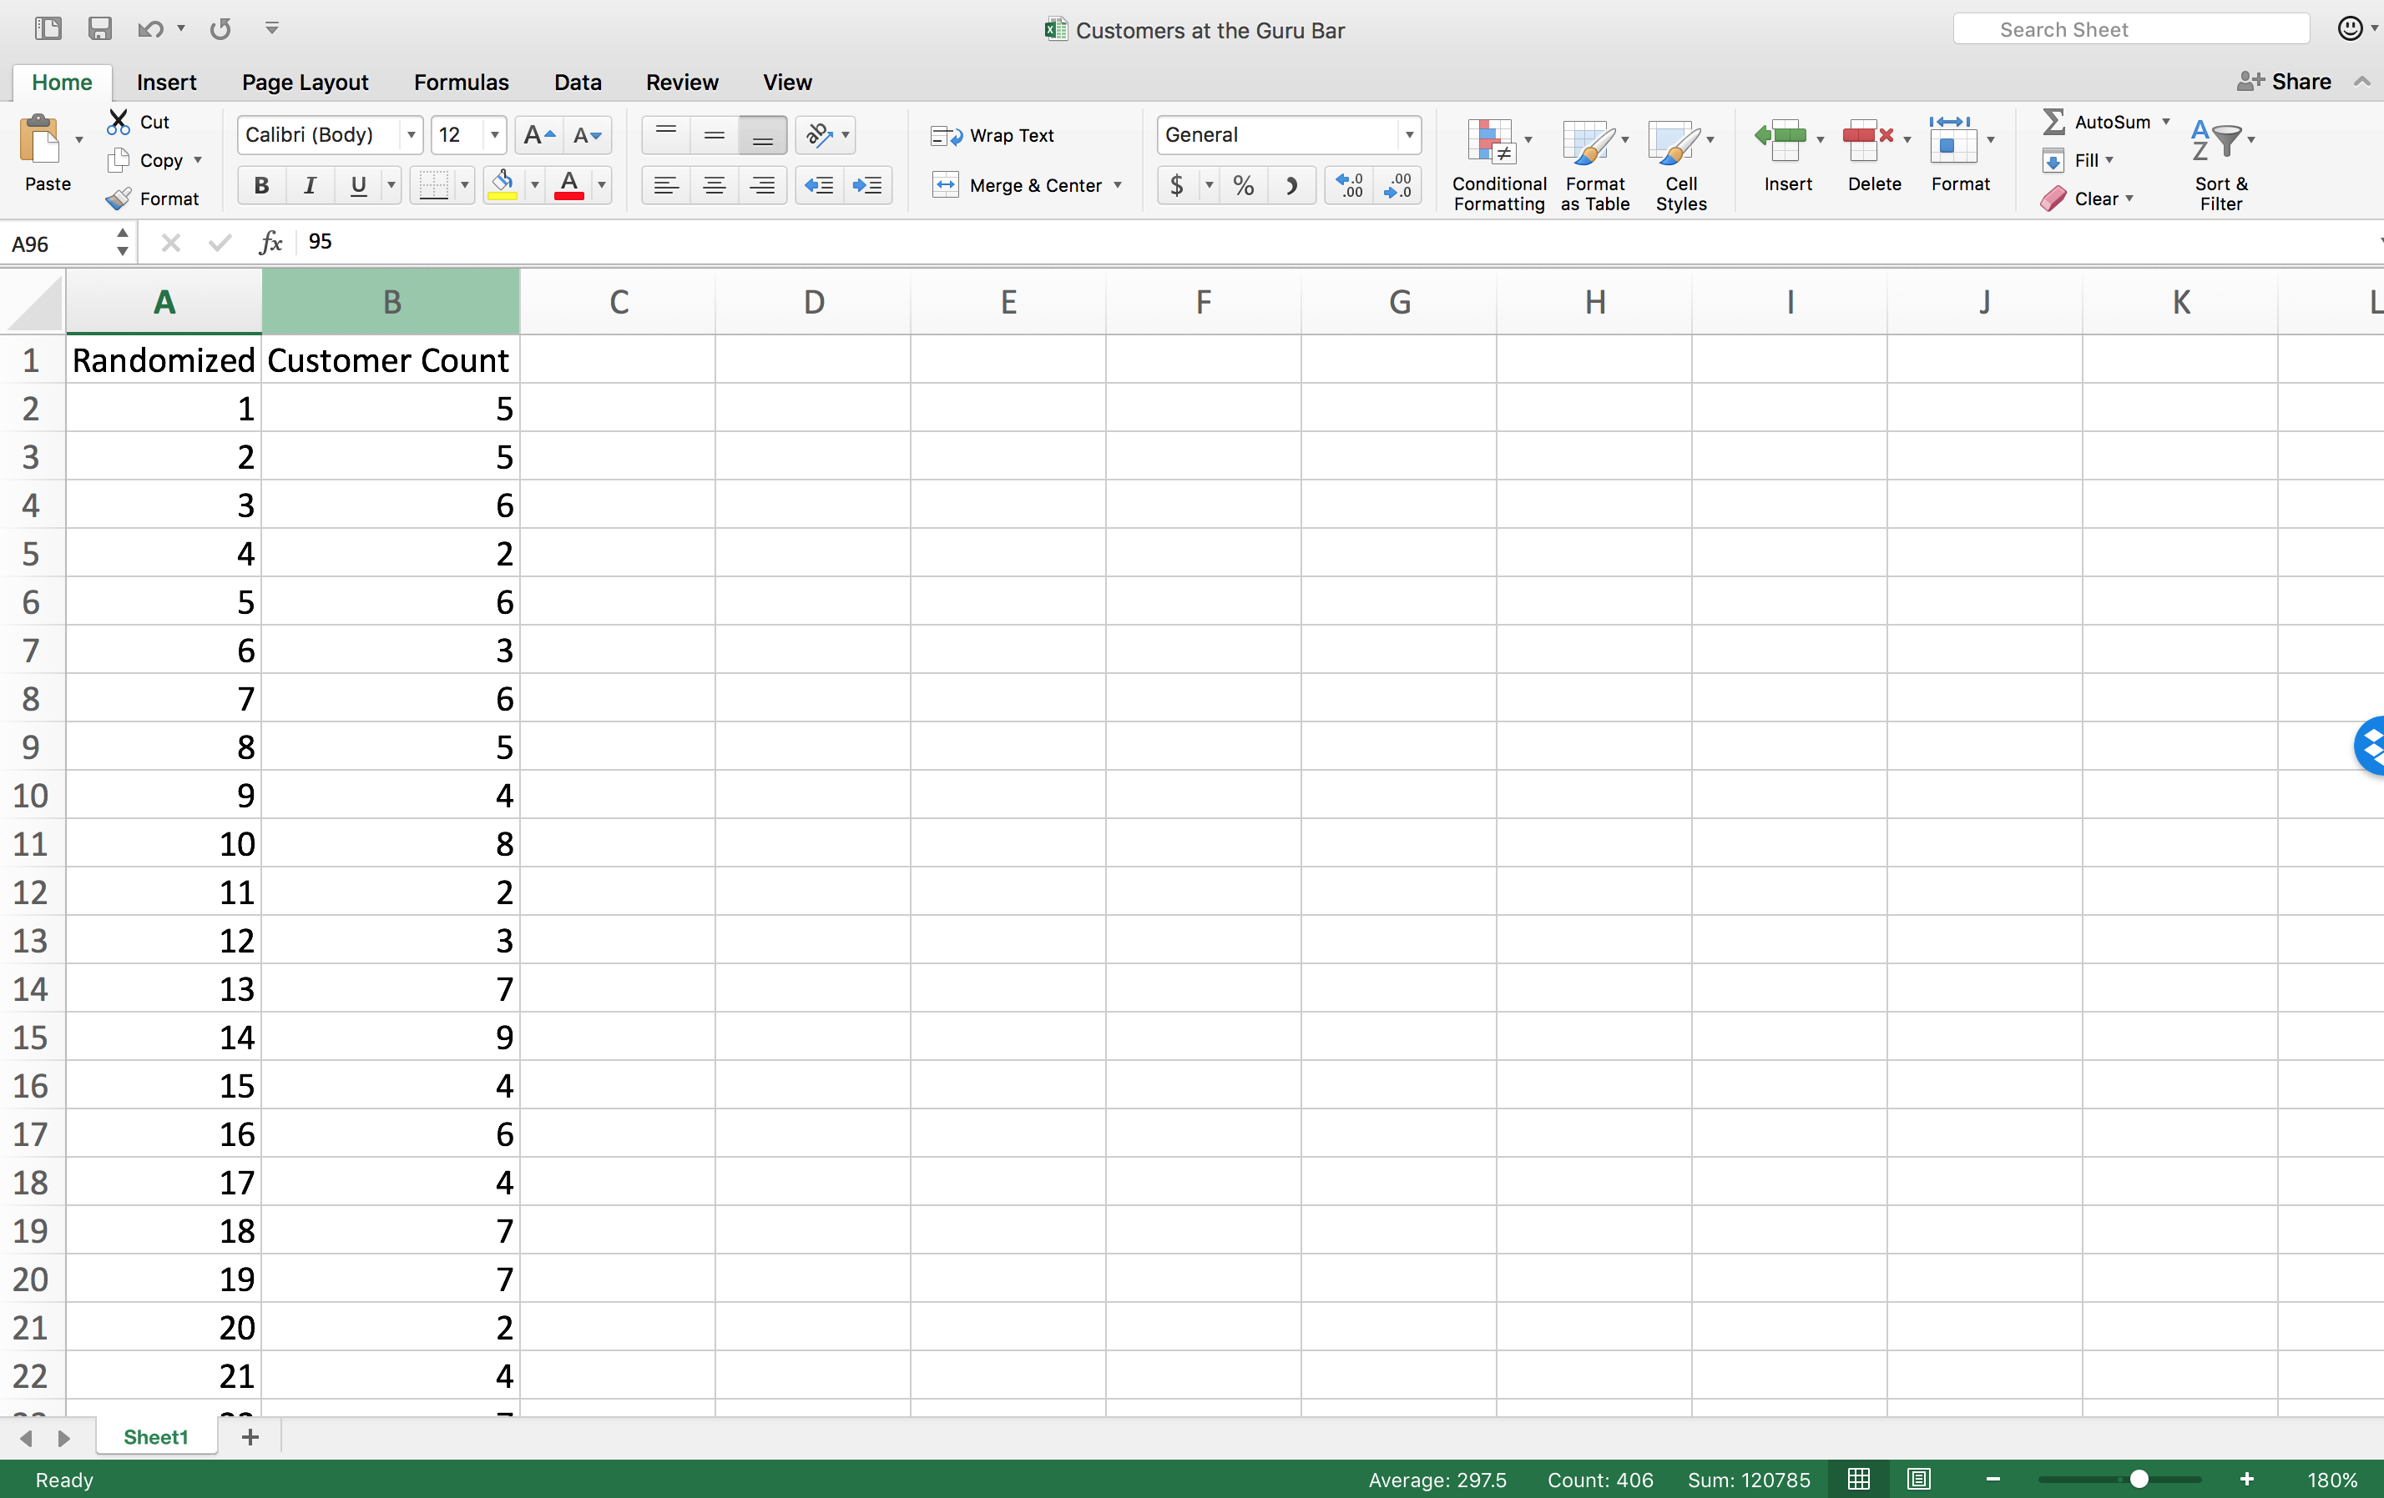

Step 2:

Find the mean of the count distribution.

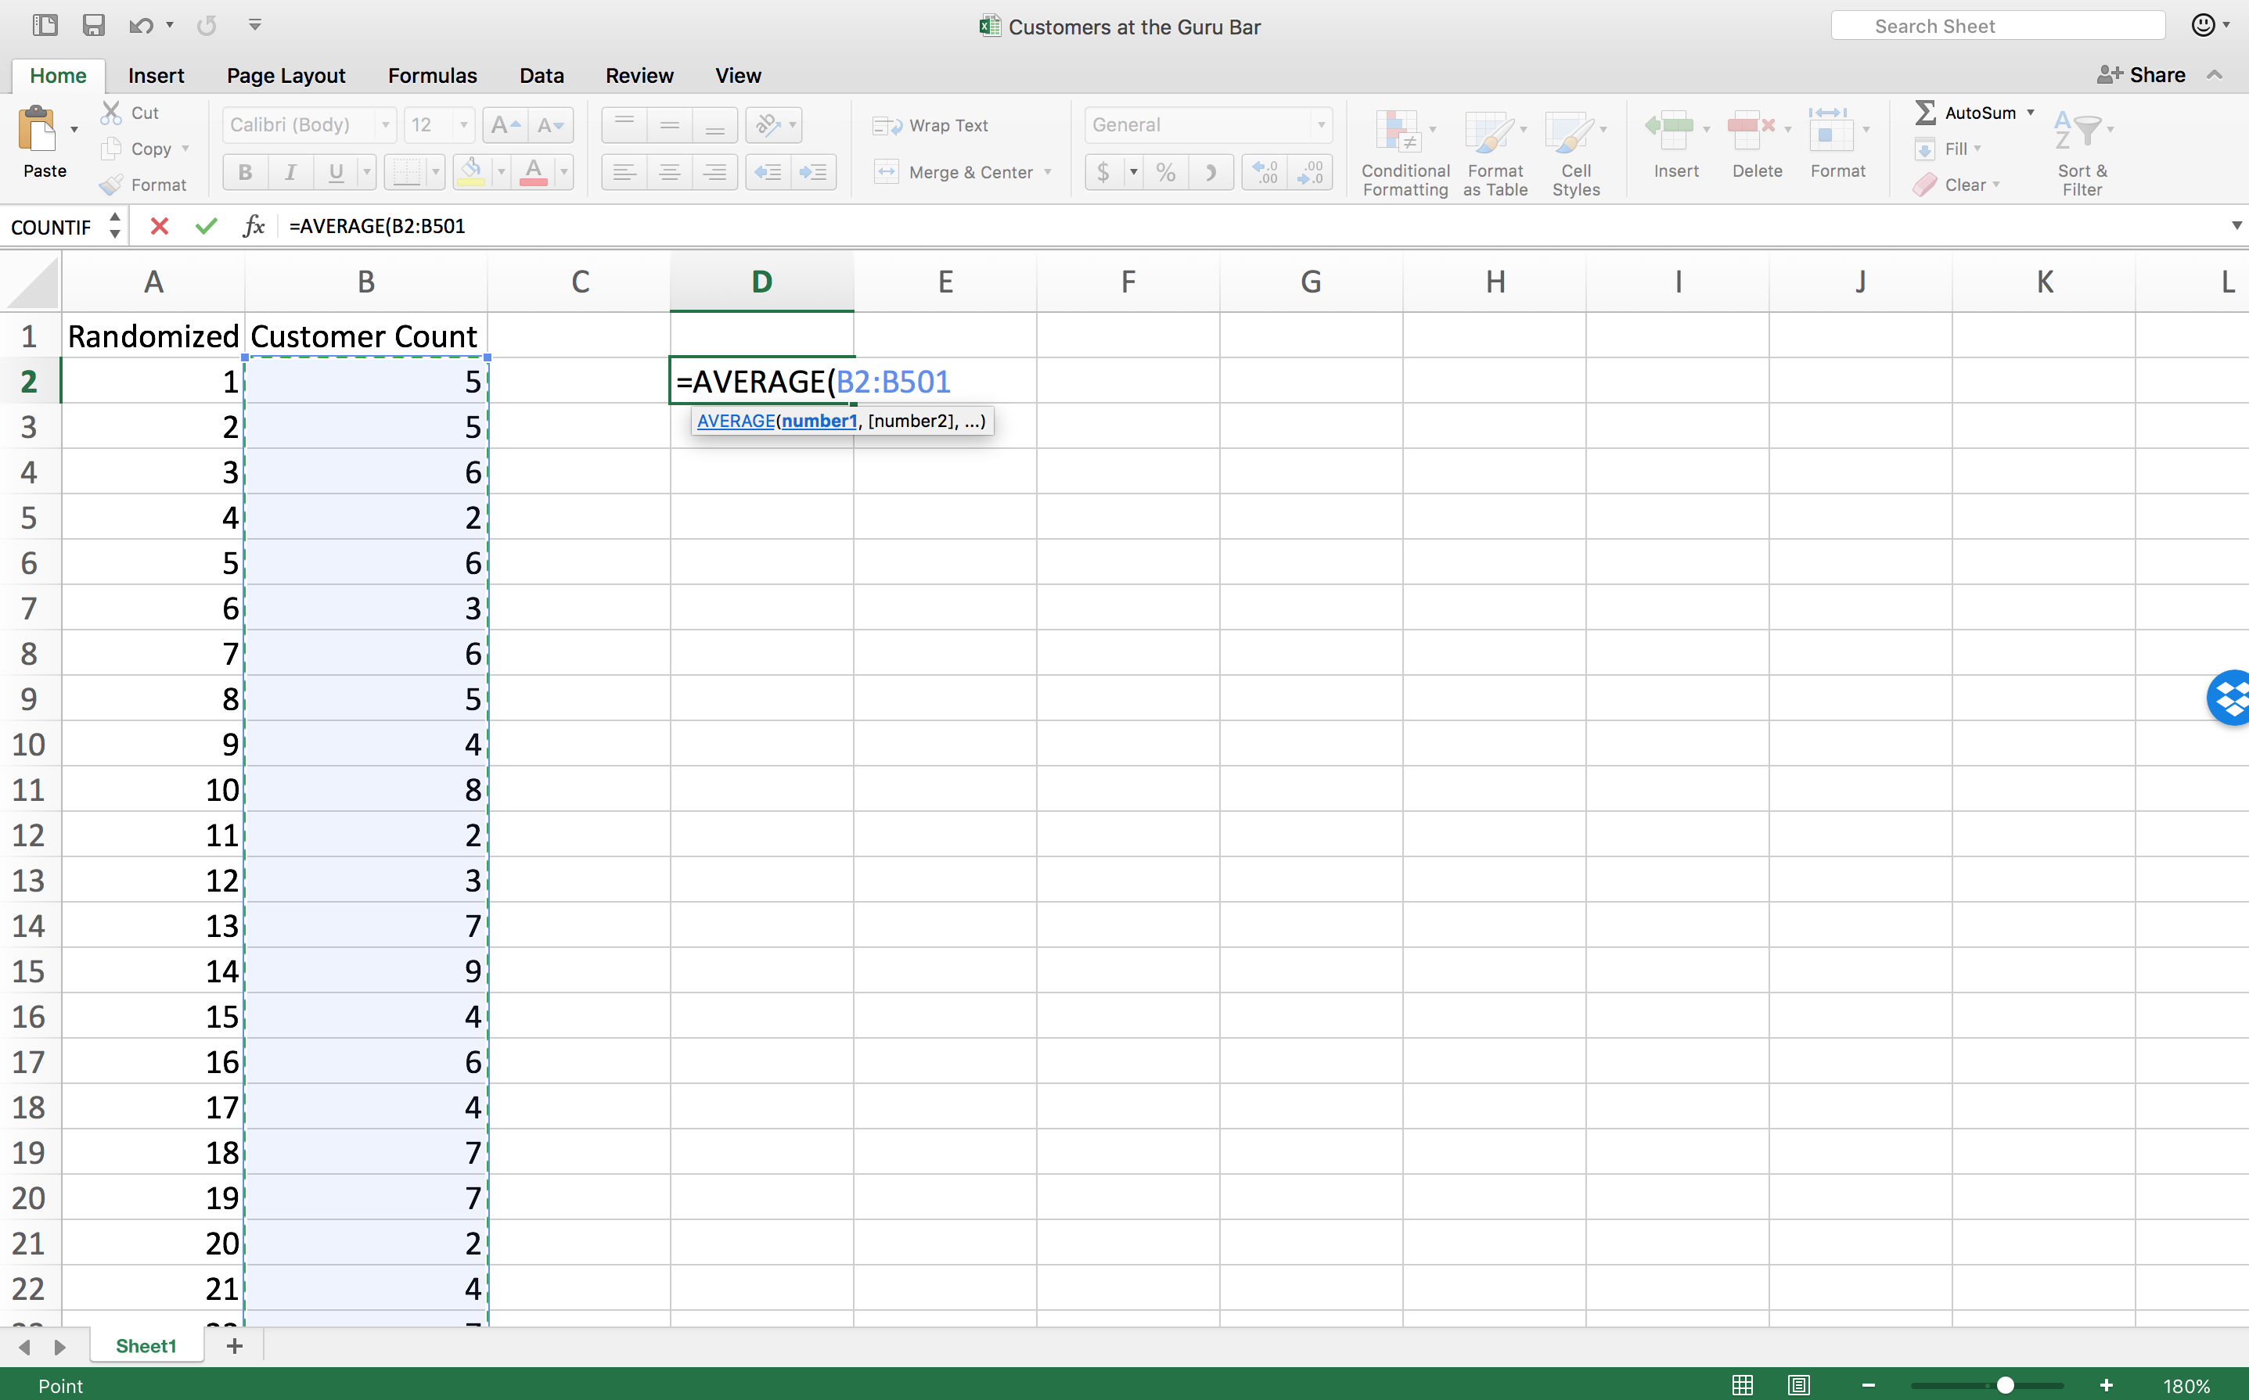

Step 3:

Note that it is 5.05 customers per hour (the mean) even though there cannot be 0.05 customers.

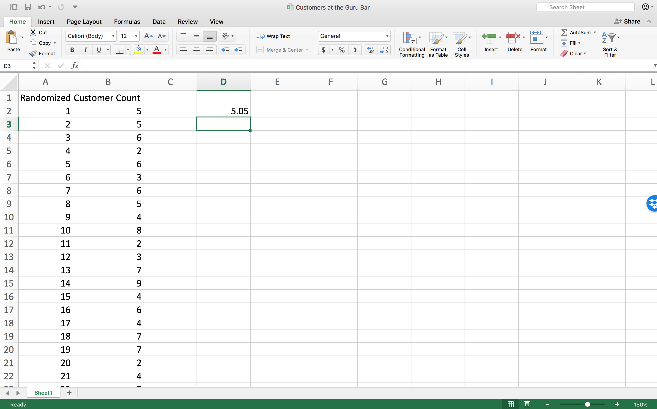

Step 4:

Use the POISSON.DIST() function to answer the question about the probability that there will be 6 people at the bar in a given hour.

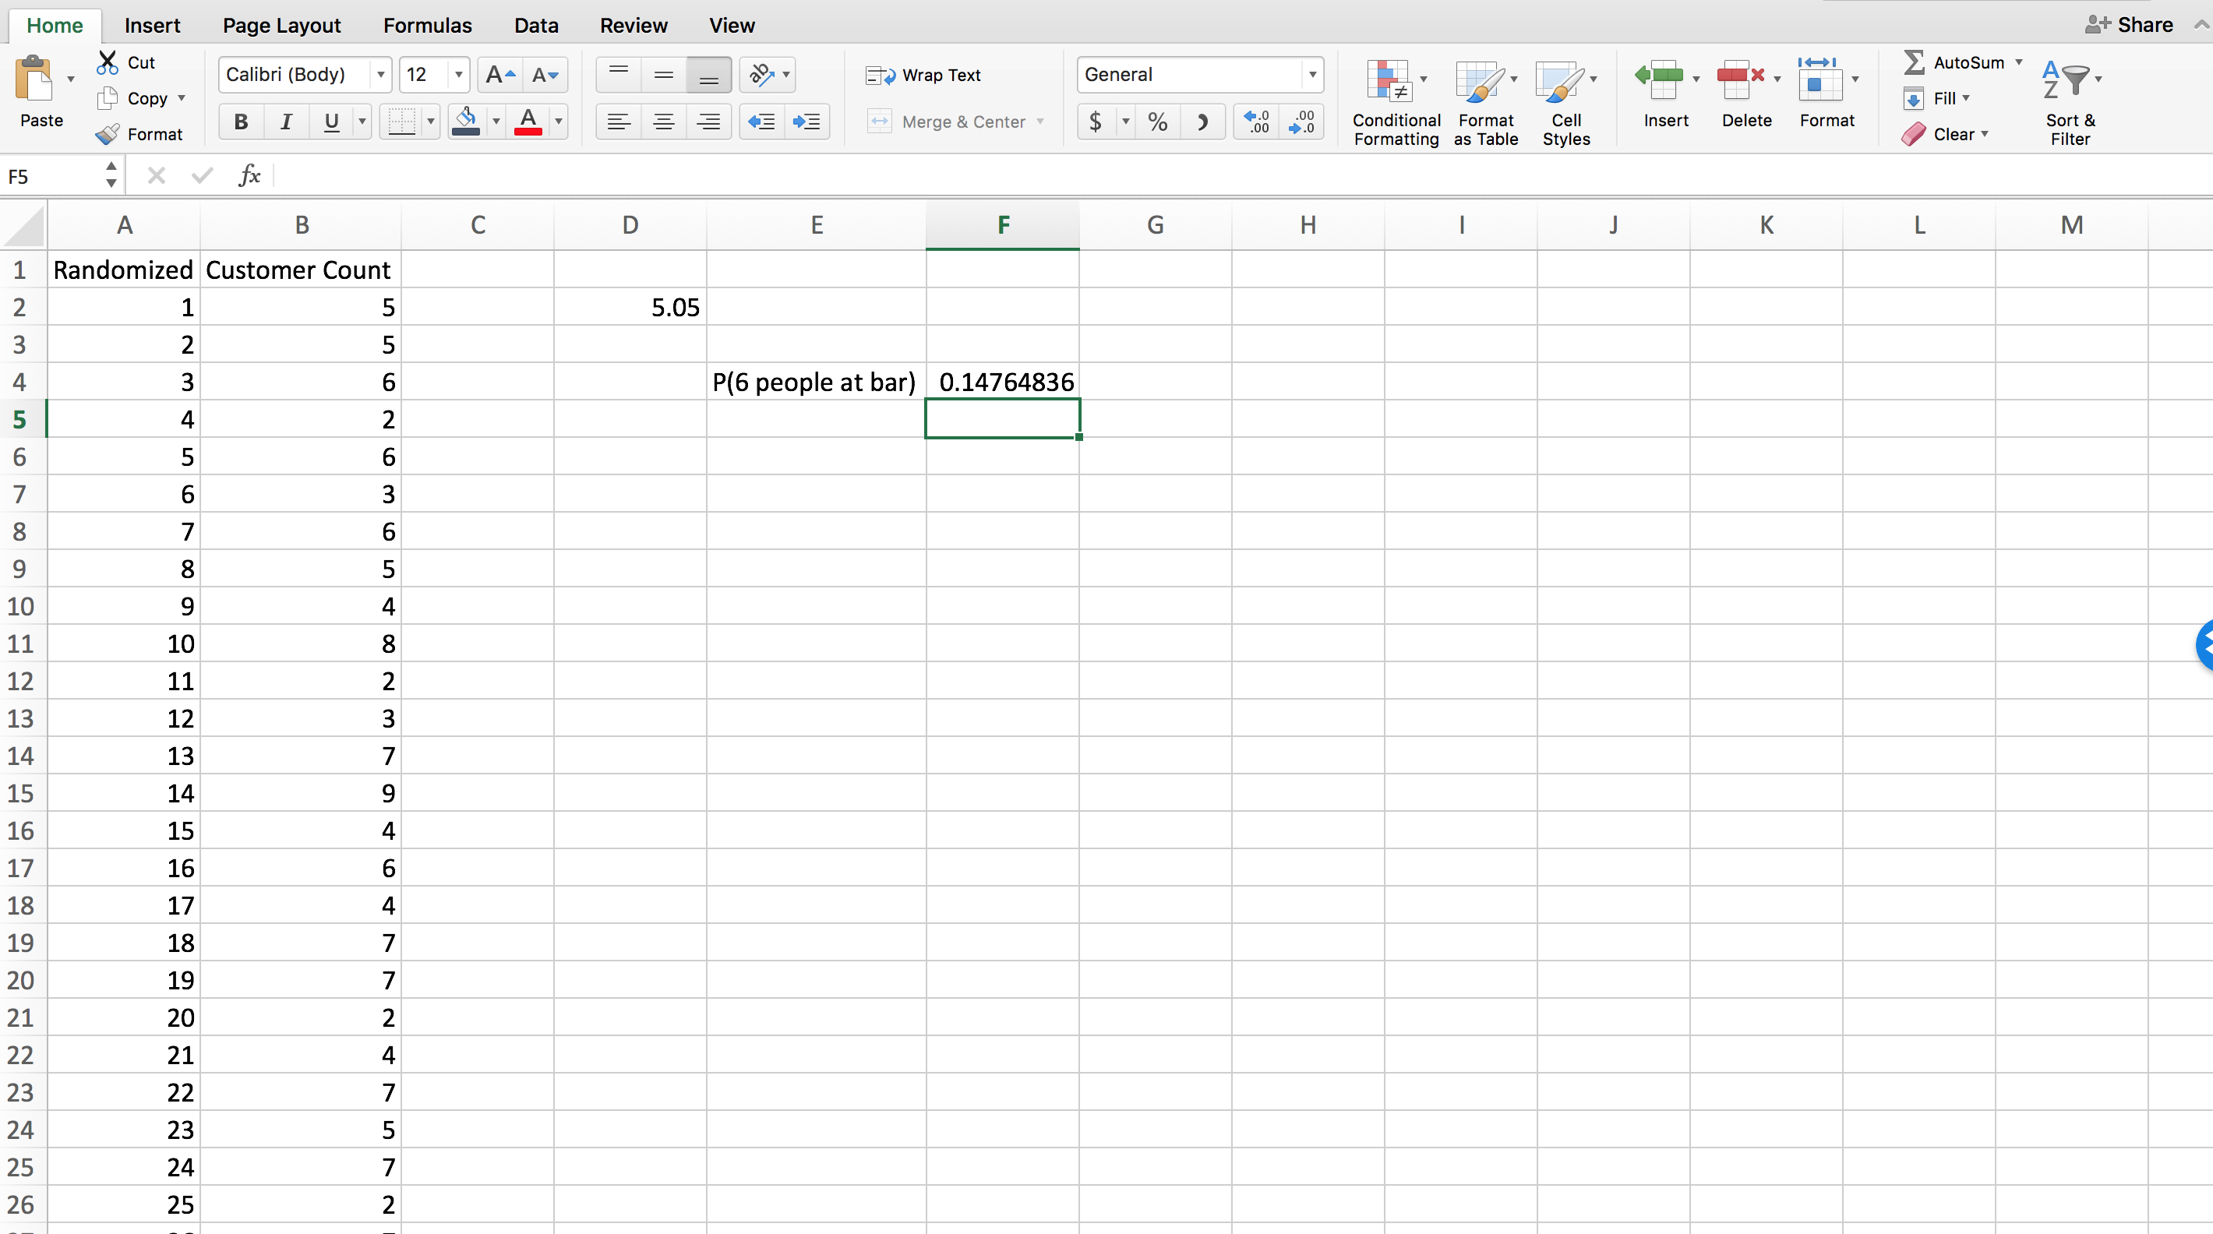

Step 5:

Change the value of CUMULATIVE from 0 to 1 to calculate the probability there will be up to 6 people at the bar in a given hour. Note the difference in language: the first is exactly 6, the second is from 0 to 6.

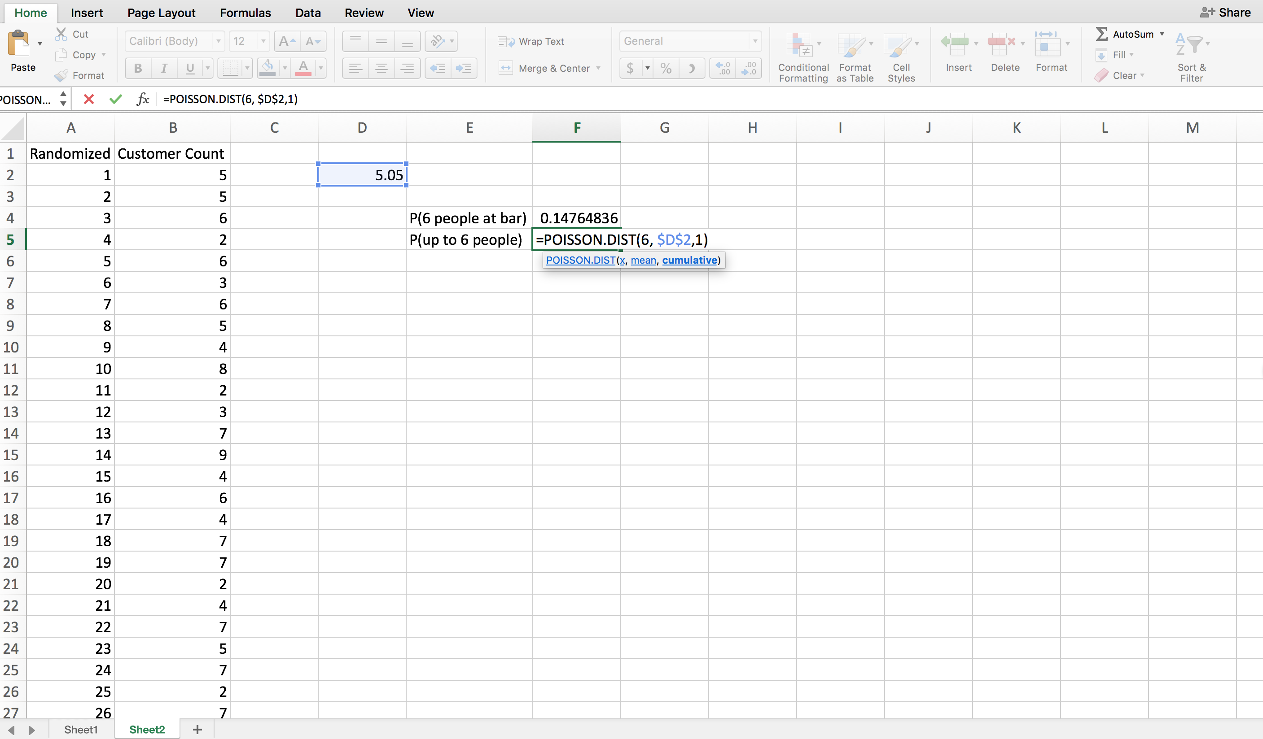

Step 6:

Notice that the probability of from 0 to 6 people is 75%.

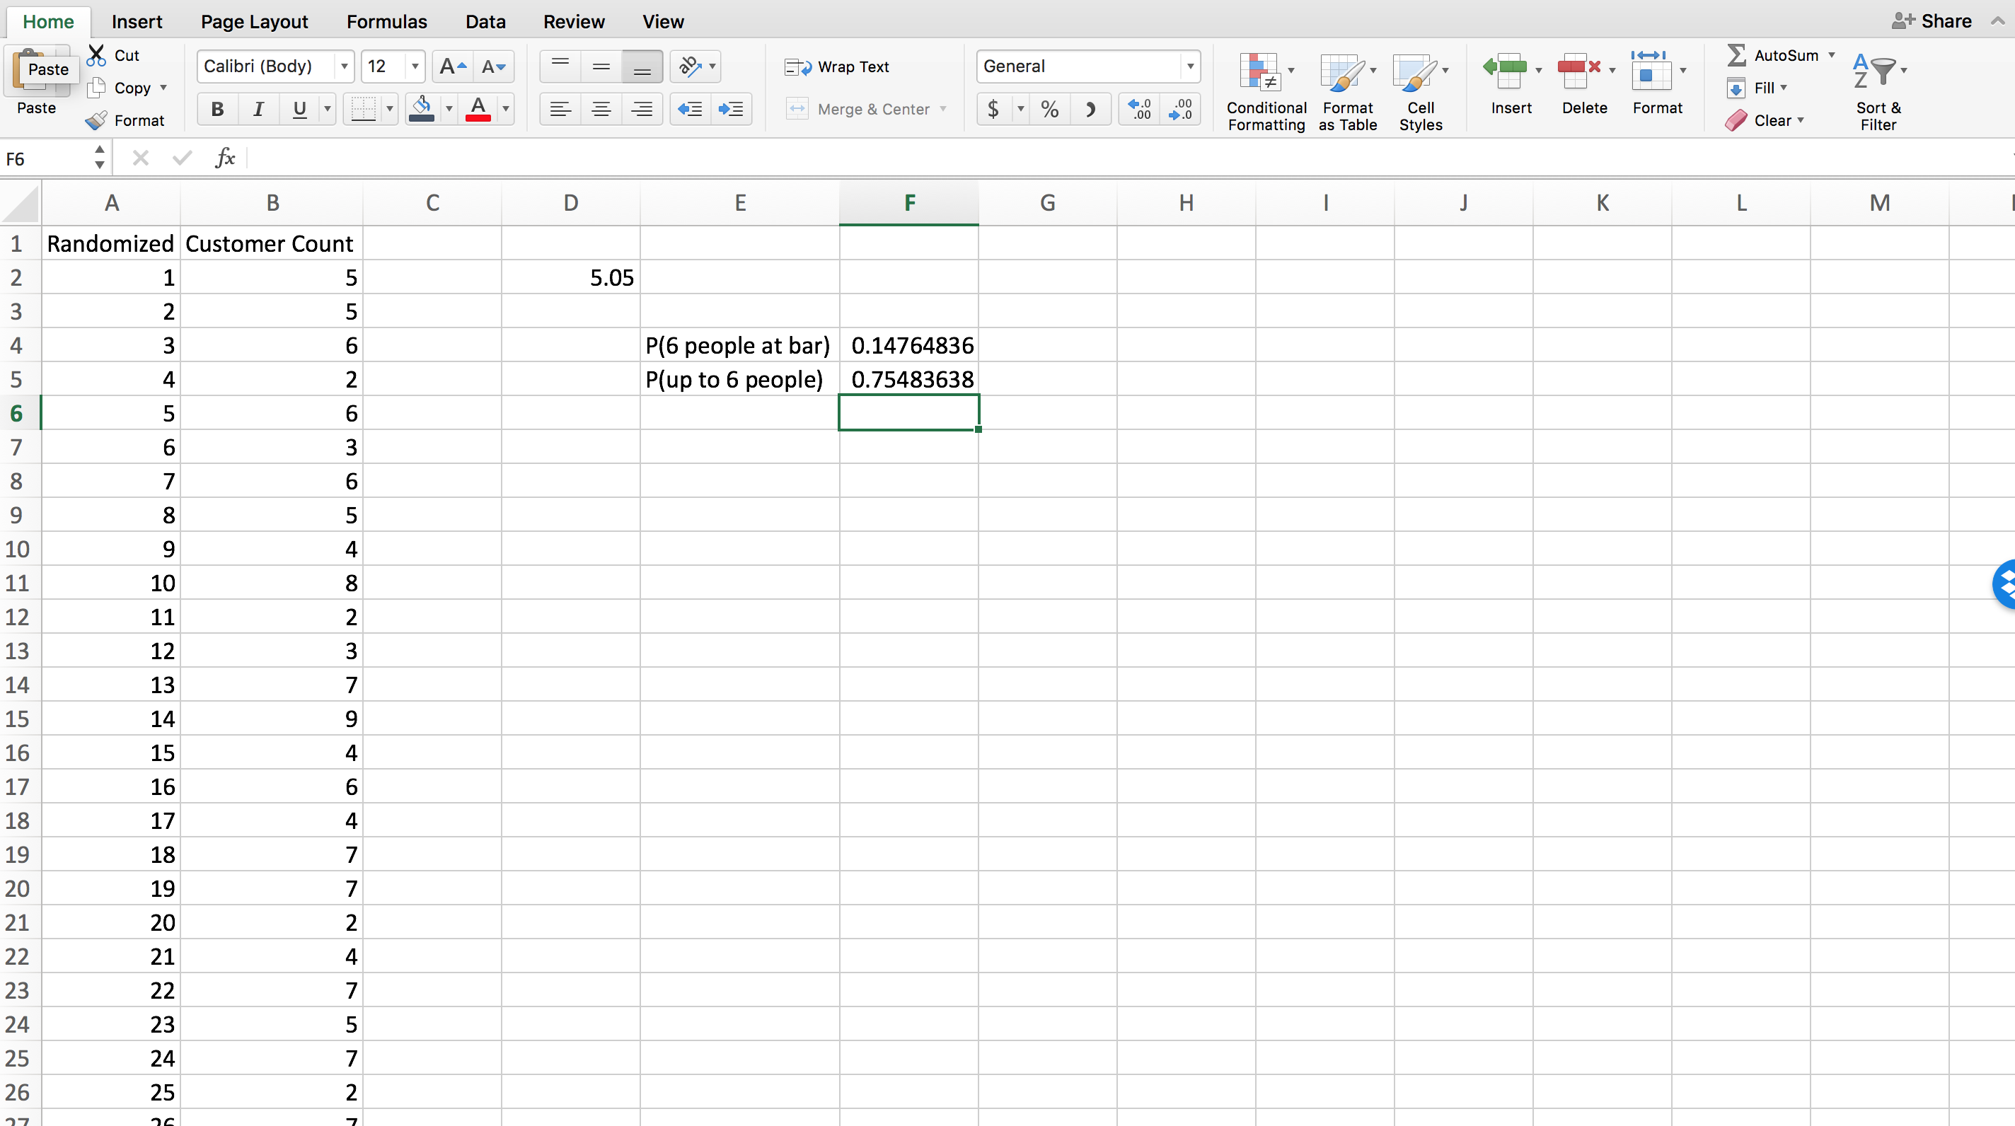

Step 7:

The next is uses the probability of “from 0 to 6” then subtracts it from 1 to find the probability of “greater than or equal to 7”. The answer is approximately 25% as it should be from P = 1 -0.75.

